# Drain Monitoring System using IoT

##### **Anand Vijayan­­­­1, Jones K Cyril1, Kevin Benny1, Wesley K Thomas1, Debashreet Das1**

1Computer Science Engineering, Karunya Institute of Technology and Sciences

***Abstract*-** *Drainage systems present in a territory play a vital role in the health and hygiene of both the surrounding environment and people present in the area. Overflow of drain water and leakage of sewer gases can disrupt the regular functioning of the surrounding areas and cause health issues to workers. Solving such an issue requires regular monitoring of drain or manhole systems to track changes in the level of water monitor the ambient temperature and humidity and detect the presence of toxic gases. The changes can be reported to the authorities who can take the necessary actions. In this paper, we have proposed an IoT based technology to create a system that will monitor, track, and report the above-mentioned parameters using various sensors. The data will be collected and displayed in a cloud platform and alerts are sent based on threshold values.*

***Index Terms***- Internet of Things, Drainage monitoring, Cloud, Sensors, Raspberry Pi, Arduino

1. Introduction

Health and hygiene play a crucial role in the modernization and development of cities. With urbanization and promotion of smart cities in developing countries such as India, public sanitization and drainage systems must be combined with the latest technologies to improve in efficiency and provide cost efficient solutions. The current system is quite ancient and poses risk to the surrounding life. The number of people who died in sewer related accidents rose to 110% by 2019. Manual scavenging has always been a problem without a solution. There is no way to know the conditions inside a drain system for cleaning and maintenance. Hydrogen Sulphide gas leakage in drains cause immense risk to the surrounding. Current drain systems are prone to sewer water overflow and leakage of toxic gases which can have detrimental effects on the surrounding environment and life in it.

This paper suggests a possible solution in solving this issue using sensors that will monitor the required parameters and send the data to a cloud platform which are archived as well. General public can view the data in real-time and in graphical format. Authorities can view the conditions of such systems before taking the necessary action. The solution also provides alerts which are triggered when the sensor data cross certain threshold values and ensure they are reported to the authority before a major problem arises.

The below sections will discuss the various existing proposals and solutions. The detailed and systemic process of the entire system will be discussed.

2. LITERATURE REVIEW

There have been various proposed solutions to solve the problem and we will go through and discuss some of the relevant ones.

A paper by Sathiya et al. proposes a model to monitor underground drainage using an IoT system. An Arduino to control the sensors, which includes a temperature sensor, gas sensor and a buzzer for alert. An ultrasonic sensor is used for sewage detection as well. The sensor values are sent to the cloud using a Node MCU and SMS alerts are setup using GSM. An ultrasonic sensor is not suitable for enclosed spaces. Security of the system is not considered [1]. Another paper by Sultana et al. proposes a similar model as above. Uses the same architecture and combination of sensors and GSM and Node MCU to send the data and trigger alerts. Once again, the security of the system is not considered [2]. A paper by Bhanujyothi et al. uses a similar architecture with emphasis on mobile devices to monitor the data. It is a simple solution which uses only a flow and gas sensor. A GPS module enables to send the location of the drain or manhole in the alert. A cheap GPS module will be very difficult to setup if the monitoring system is underground and or if the GPS is enclosed. An alternative is however expensive [3]. A paper by Aditya et al. again focuses on mobile application with data being sent to a database. This model focuses only on sewer gases with various gas sensors and an Arduino. Gas leak and concentration can be tracked effectively, and little attention is given to application security. However, fails to monitor other important parameters [4]. A paper by Girisrinivaas proposes a similar and simple model which uses an ultrasonic sensor to monitor water level, a gas sensor, and a tilt sensor to prevent theft. As said before an ultrasonic sensor is unsuitable in such spaces [5].

After reviewing the related work, we find that a systematic and standardized process for drain monitoring does not exist. Moreover, an efficient alert system must be developed to improve the efficacy of the overall model. Security, another major concern also needs to be addressed. The model proposed in this paper addresses the above issues to create and efficient reliable, cost effective and secure drain monitoring system. This is achieved by using the necessary sensors with a real time monitoring system and alert mechanism. The monitoring system is based on cloud, data is collected and processed using a micro controller and raspberry pi device, and alerts are triggered using remote API calls.

3. PROPOSED SYSTEM

A. COMPONENTS USED

We need to monitor, in real time - various aspects which determine the health of the drain system. These include the temperature/humidity, air quality and level of water. To achieve this we use a Water Level Sensor, DHT11 temperature and humidity sensor and an MQ135 gas sensor. These sensors are not of industrial standards and are purely for a prototype. We make use of an Arduino UNO microcontroller to control our sensor devices along with a Raspberry Pi 3B. The Arduino controls our sensor devices and the raspberry pi is used to process the data and upload the necessary information to the cloud. This approach reduces the processing load on the raspberry pi. The Pi device gives us a flexible interface for programming using Python. This approach reduces the processing load on the raspberry pi. The two devices (Raspberry Pi and Arduino) exchange data using the *Firmata* protocol which enables us to control the Arduino from the Raspberry Pi.

In addition, we use a tilt sensor to detect any unwanted movement including theft of our system along with an LCD display to show the sensor data outside the cloud. Alerts are set up in the cloud platform and alerts are triggered based on preset threshold values which are again automated remote API calls. The data is sent via API to the cloud service which displays it in various visual forms. The cloud platform also enables downloading archived data for further processing or analytics.

B. ARCHITECTURE

The entire workflow of the proposed system is divided into three different stages according to Fig1 below. The first stage includes all the input/peripheral sensor devices. The required physical parameters are sensed in this stage. The MQ135 gas sensor, water level sensor and tilt sensor are connected to the Arduino. These sensors transmit analog values to the Arduino. However, the DHT11 temperature and humidity sensor is connected to the raspberry pi. This sensor is capable of transmitting digital data. The second stage of the model includes the transmission of the sensor data to the raspberry pi. The analog values from the Arduino are accessed by the raspberry pi using the *firmata* protocol. Inside the raspberry pi we use python to create modules for reading data from various sensors. In the third and final stage we connect to the cloud platform to display the sensor data. The data is also displayed on the LCD screen. The data is send using HTTP and is connected to the cloud platform using API keys. Alerts are configured in the cloud platform based on threshold values.

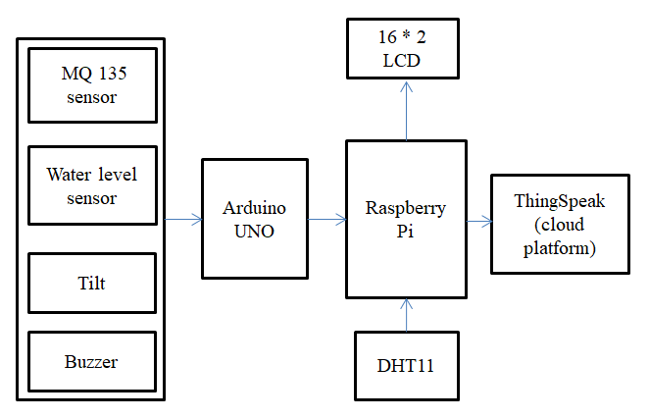

Fig1. Architecture Block Diagram

As far as security is concerned, both device security and network security is taken into consideration. The tilt sensor helps again possible theft or vandalism. The raspberry pi is accessible only via ssh and is thus not secure. Use of ssh keys reduce the probability of *brute force* attacks. Further protection is enabled using additional firewall software which block all the unnecessary ports and can also monitor the ssh port. This also enables blocking/banning IP’s that show suspicious behavior. Application security is purely dependent on the platform service provider.

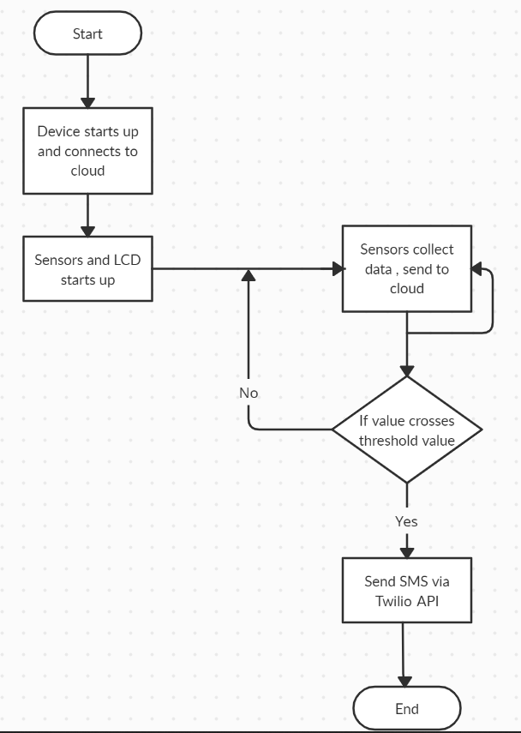

Fig2. Flow chart of the process

In Fig2 we understand the process workflow. Once the system is initialized it starts collecting data and sending it to the cloud service. Since our alert mechanisms are set up on the platform we can ensure loose coupling between them.

Since the data is live, authorized entities can monitor even if the alarm system fails. Alarm messages can be unique based on the requirement and can be configured in the platform itself.

The cloud service platform works on a subscription basis and the latency in which data is sent depends on this. A latency of 15 seconds is available in the free version. This can bring considerable delay but also reduces the overall cost by a huge margin.

4. EXPERIMENTAL ANALYSIS

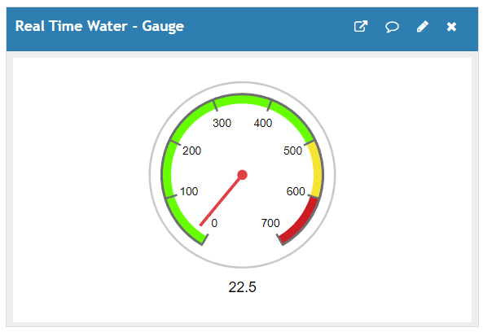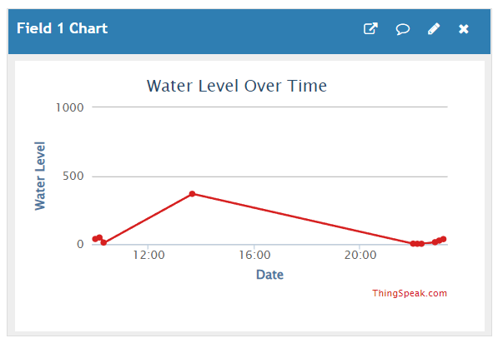The prototype was built using the sensors and controller devices and was tested under controlled conditions as accesses to drains are limited due to the sensitive nature of the prototype device. The assembly is placed in a casing to for easier handling. The following are the results recorded by the ThingSpeak cloud platform over the course of the testing.

Fig3. Water Level Graph and Gauge

Fig3 shows the water level reading in two formats. The graph shows us the water level over time. The Water Level sensor shows values from beginning from 0 and the can go up to 1000 based on the sensor. Through repeated experimentation we find the following range for water level.

|  |  |
| --- | --- |
| **Value** | **Estimated Water Level** |
| <590 | LOW |
| 590-650 | MEDIUM |
| >650 | HIGH |

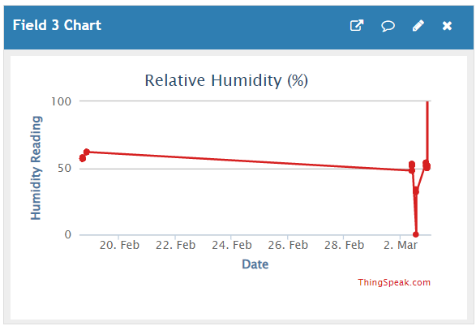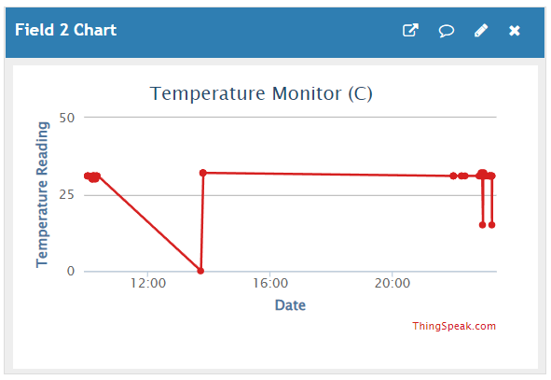We have set up Twilio API to send SMS based on these values automatically using our ThingSpeak Cloud platform.

Fig4. Temperature and Humidity

Fig4 shows the temperature and humidity reading in graphical format. Since the DHT11 sensor is connected to the GPIO pins of the Raspberry Pi device we get the data in Celsius for temperature and the Relative Humidity in %. Based on data from external sources we have decided the threshold values for sending out alerts. They are as follows

|  |  |
| --- | --- |
| **Reading** | **Alert Threshold** |
| Temperature | > 50 C |
| Humidity | > 90% |

Again, based on these values we set up the alert messages in the cloud platform.

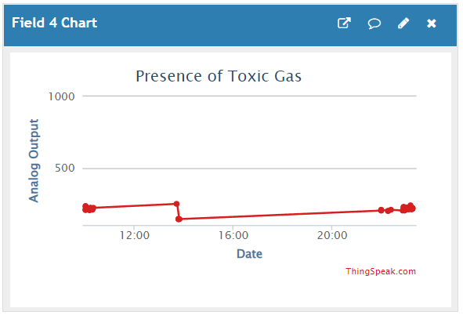

Fig5. Toxic gas Graph

Fig5 shows us the level of toxic gas detected. The values are based on the concentration of sulphides or methane in the atmosphere to which the MQ135 is sensitive to. The threshold values are based on experimental analysis as real-time conditions are difficult to recreate. The following table shows the threshold values.

|  |  |
| --- | --- |
| **Value** | **Toxic Level** |
| > 500 | HIGH |

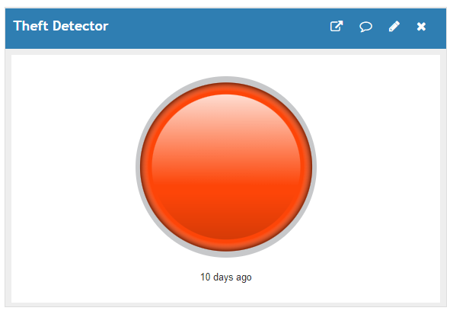

Fig6. Tilt Indicator

Fig6 shows the tilt detector indicator in our cloud platform. The tilt sensor is a digital sensor and sends either 1 or 0. If it’s in a tilted position 1 is send via the Arduino and lamp indicator turns on. The buzzer also goes off for a period of about 10 seconds. The alert message is again sent based on the threshold value, which in this case is 1.

The SMS alerts are set up to send alert messages directly from the cloud. Due to the free subscription we are using the messages are sent with a delay. Fig7 shows how these messages look which were recorded during the experimental analysis of the prototype system.

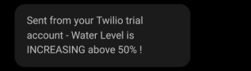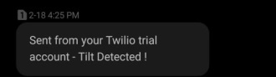

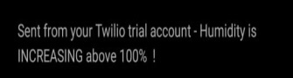

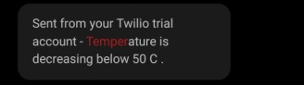

5. CONCLUSION AND FUTURE SCOPE

Drain monitoring is an important area which requires considerable attention. Improper maintenance and lack of continuous monitoring can cause leakage of toxic gases and drain water overflow which can disrupt its normal functioning. Especially in metropolitan cities which are very active during the daytime any such disruption can be fatal. The solution that is proposed in this paper is an effective solution that is cost efficient while considering the efficiency as well. Implementing this model can ensure timely monitoring of drain systems which in-turn can assist in timely alert with respect to the conditions inside the drain. This simple solution takes in the sensor values and sends it to a cloud platform that can be accessed by the public. Alerts are sent to the authorities in case of any disruption to the normal flow of the drain condition. This solution also ensures that the IoT device is safe from possible security attack and theft using network firewalls which continuously monitor the network and ban IP’s that are possible intruders. Access is limited by enabling SSH key based authentication ensuring complete security.

As far as the future of this proposed model is concerned there are a lot of areas which can be improved or further enhanced. Having a subscription in the cloud platform allows for instant detection and alerts. This model is limited to a prototype but with industrial grade sensors and protective casing it can be a complete solution that can be deployed in real time. The current model is powered by an external power source connected to the Raspberry Pi. This requires recharging once the battery is drained out. A real time implementation requires continuous power that is cheap and safe. Harnessing solar energy can be an efficient way to ensure uninterrupted power supply. As mentioned before the sensors used in building this prototype are of a lower grade and are prone to corrosion and damage on prolonged use. In the future more standard, industrial grade sensors can be used to ensure accurate and precise readings paving the way for a much efficient drain monitoring system.

6. REFERENCES

1. Dr.S.Sathiya Priya et al. “DRAINAGE OVERFLOW & MANHOLE MONITORING & DETECTION USING ARDUINO & NODE MCU” -*IRJET*
2. Sultana, Samiha & Rahaman, Ananya & Jhara, Anita & Paul, Akash & Uddin, Jia. (2021). An IOT Based Smart Drain Monitoring System with Alert Messages. 10.1007/978-3-030-68452-5_9..
3. Ms.Bhanujyothi H.C et al. “SMART DRAINAGE MONITORING SYSTEM USING IOT” - JAT
4. Aditya Patel et al. “Drainage Monitoring System Using IoT” - IJREAM
5. R. Girisrinivaas, V. Parthipan ”Drainage Overflow Monitoring System using IoT (DOMS)”
6. Romanova, Anna & Mahmoodian, Dr. Mojtaba & Alani, Morteza (Amir). (2014). Influence and Interaction of Temperature, H2S and pH on Concrete Sewer Pipe Corrosion. International Journal of Civil, Architectural, Structural and Construction Engineering. 8. 592-595.
7. Rutvik Patel et. al. “IoT based wastewater spillage detection system” ICCEMME 2021